Potential Gamification Features

Can You Save Sir Dewey? Application

Jessica Erasmus

Table of Contents

Introduction 2

Feature 1 – Progress Bars 2

Feature 2 – Achievements/Rewards 2

Feature 3 – Leader boards 2

Feature 4 – In-App Currencies 2

Feature 5 – Points-based System 2

Chosen Feature 3

Conclusion 4

References 5

# Introduction

It is said that many learn best when interacting to real life scenarios. While traditional learning methods are becoming more out-phased, gamification is becoming more of a demand, especially in the learning sector. Consider the following advantages of gamification:

* Encourages Out-of-the-Box Thinking
* Maximizes Attention Span
* Encourages Accomplishment
* Creates A Healthy Competition, in most cases

# Feature 1 – Progress Bars

Progress bars help and show the user how far they are from completing a task and reaching the next level. The idea is to help the user progress through levels at their own pace without losing determination (Georgiou, 2020).

# Feature 2 – Achievements/Rewards

“Which is better- Hitting scores for a half-an-hour session or unlocking rewards after completing a task?” - Georgiou (Georgiou, 2020). This feature helps motivate and increase user engagement to application.

# Feature 3 – Leader boards

Leader boards create a powerful engagement for healthy competition and engagement towards fellow players. Appearing high on leader boards within a group of fellow players develops a sense of pride and enthusiasm for players.

# Feature 4 – In-App Currencies

Experience points are usually enough by itself for beginner users to be proud of. However, an app having its own currency so that users aim to earn a certain amount to purchase what they desire. Consider RPG games in terms of XP outfits, new outfits, limited edition items, weapons, or extra lessons.

# Feature 5 – Points-based System

The point system uses a gamified strategy to reward the user. The difficulty in this feature is implementing the point system into the design thoroughly throughout application use (Brown, 2019). Its important that the point-based mechanics encourage positive behaviour which supports with the project objectives (Brown, 2019).

# Chosen Feature

When choosing a specific gamification feature, ability and complexity is important to consider. Consider the diagram below as a representation for gamification 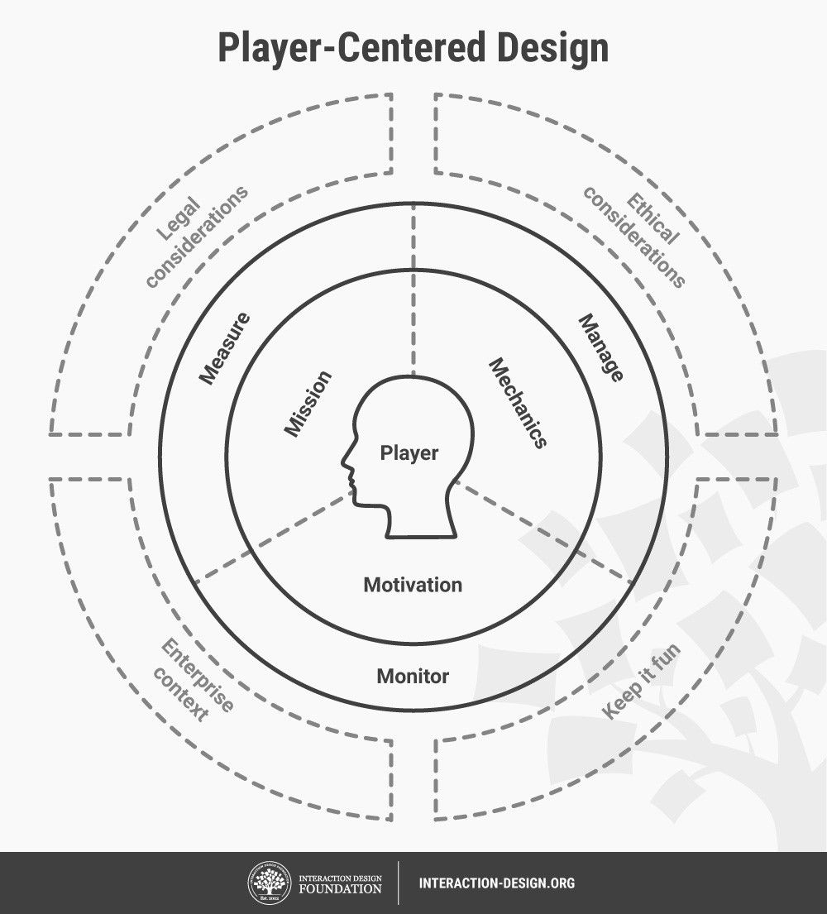

Hence, considering all factor with the model, I chose to mainly implement a point-based system since it was the feature I felt fits best towards the aplication idea at the moment. Within later progress of the application, I will intend to add some slight features based of the other mentioned features along with a bit of storytelling.

# Conclusion

To get gamification right, understanding that motivations will vary according to the task, objective and player is vital. Therefore, progress bars, leader boards, in-app currency, points-system, and achievements are a quick and straightforward way to gamify an eLearning project (Baraishuk, 2018). Gamification features do however set an investment for user loyalty and satisfaction (Baraishuk, 2018).

# References

Baraishuk, D., 2018. *5 Most Popular Gamification Features (With Examples).* [Online]   
Available at: https://elearningindustry.com/gamification-features-5-most-popular-examples  
[Accessed 15 Aug 2022].

Brown, D., 2019. *Gamification features.* [Online]   
Available at: https://www.edapp.com/blog/gamification-features/  
[Accessed 15 Aug 2022].

Georgiou, M., 2020. *8 Essential Gamification App Features The Education Sector Needs.* [Online]   
Available at: https://imaginovation.net/blog/gamification-education-app-features/  
[Accessed 15 Aug 2022].

Interaction Design Foundation, 2022. *Gamification.* [Online]   
Available at: https://www.interaction-design.org/literature/topics/gamification  
[Accessed 15 Aug 2022].

Pappas, C., 2014. *The Science And Benefits Of Gamification In eLearning.* [Online]   
Available at: https://elearningindustry.com/science-benefits-gamification-elearning  
[Accessed 15 Aug 2022].